**Dr. N.G.P. INSTITUE OF TECHNOLOGY**

**(An Autonomous Institution)**

**DEPARTMENT OF ARTIFICIAL INTELLIGENCE AND**

**DATA SCIENCE**

**PROJECT REPORT**

**Submitted by**

**SAHIN NISHA N 710721243039**

**SHIVA SHANKARI V 710721243045**

**TANUSHREE K 7107212436053**

**ABSTRACT**

The Cab Booking Management System is a comprehensive solution designed to revolutionize the cab booking process. Utilizing a user-friendly frontend developed with HTML, CSS, and JavaScript, customers can easily register accounts and book cabs through an intuitive form. The backend, powered by server-side scripting, efficiently processes booking requests, providing real-time updates on car availability. Secure connectivity with a relational database ensures the safe storage and retrieval of customer details and booking information, implementing HTTPS and data encryption for heightened security. Administrators benefit from a robust backend dashboard, offering tools for effective booking management and insights through detailed reports. The project aims to enhance the overall efficiency, security, and scalability of cab booking services, contributing to improved transportation experiences in urban environments. By providing a standalone system, the Cab Booking Management System strives to simplify the booking process for customers, ensuring a seamless and reliable platform for modern transportation needs.

**INTRODUCTION**

The Cab Booking Management System, leveraging HTML, CSS, JavaScript, and servlet integration, emerges as a pivotal solution in the rapidly evolving landscape of transportation services. The Cab Booking Management System bridges this gap by offering a unified platform that seamlessly integrates user-friendly interfaces for customers and robust management tools for service providers.

At its core, HTML lays the foundation for the system's front-end, providing the structural framework for web pages and forms. These HTML forms, enhanced by CSS styling, offer an intuitive and responsive interface, ensuring a consistent and aesthetically pleasing user experience across diverse devices. JavaScript, operating on the client side, introduces dynamic elements such as real-time form validation, interactive date and time pickers, and user-friendly alerts, elevating the overall usability of the application.

On the server side, Java servlets play a central role in handling business logic and database interactions. They manage user authentication, validate booking requests, and facilitate secure data exchange with the relational database. This integration ensures the persistence of crucial information, including user details, cab availability, and booking history. The relational database enhances the system's ability to efficiently manage data, contributing to the reliability and scalability of the Cab Booking Management System.

In conclusion, the Cab Booking Management System is not merely a technological evolution but a strategic response to the demands of a dynamic industry. Through the seamless integration of HTML, CSS, JavaScript, and servlet technology, this system emerges as a robust and user-centric solution, catering to the needs of both customers seeking hassle-free bookings and service providers requiring effective tools for streamlined fleet management. As we delve deeper into the intricacies of the system, its comprehensive approach to addressing challenges in the cab booking domain becomes increasingly apparent.

**OBJECTIVES**

1. Efficient Booking Process:

* Streamline the cab booking process to make it quick and user-friendly.
* Minimize the time and effort required for users to book a cab.

1. Real-time Availability:

* Ensure real-time availability of cabs to meet user demands promptly.
* Provide accurate and up-to-date information on cab availability.

1. Accurate Location Tracking:

* Implement robust GPS and location tracking systems for precise identification of user and driver locations.
* Minimize errors in location data to enhance overall service accuracy.

1. Payment Convenience:

* Offer a variety of payment options for users, including cashless transactions and digital wallets.
* Ensure secure and reliable payment processing to build trust among users.

1. User Experience Enhancement:

* Continuously improve the user interface and experience of the cab booking app or website.

**TOOLS**

This section gives the details of the software that are used for the development.

* **Frontend:** HTML
* **Backend:** Java Servlets for handling user requests and database interactions.
* **Database:** Relational database MySQL to store library data.
* **Development Tools:** Java IDE Eclipse

**UML DIAGRAM**

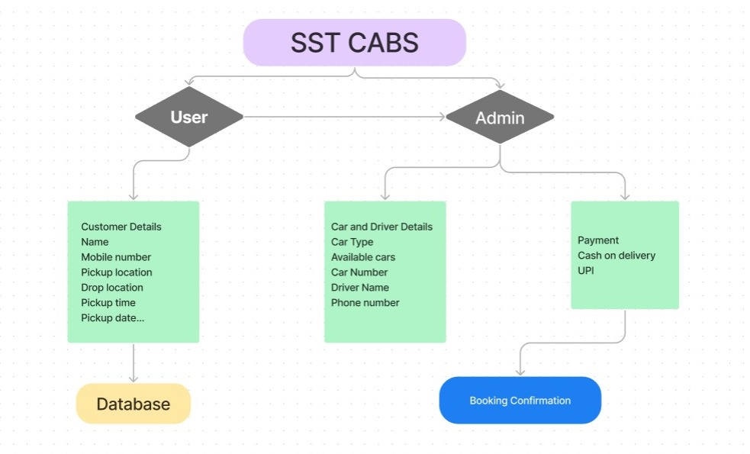

**KEY FEATURES**

1. User-Friendly Web Interface:

* The project provides a user-friendly web interface with visually appealing designs.
* The use of background images and gradients enhances the overall user experience.

1. Multi-Page Form for Booking:

* The booking process is divided into multiple pages/forms, ensuring a step-by-step and organized approach.
* Users input details such as customer name, mobile number, pickup/drop addresses, pickup date, and pickup time.

1. Car Selection:

* Users can choose from different car categories, including Sedan, SUV, and Luxury.
* Car details and options are dynamically displayed, allowing users to make informed choices.

1. Database Integration:

* User booking details are stored in a MySQL database.
* JDBC (Java Database Connectivity) is used to connect to the database and perform insertion operations.

1. Responsive Design:

* The web pages are designed to be responsive, ensuring a consistent and optimal experience across various devices.

**TECHNOLOGICAL STACK**

1. Frontend:

* HTML5: Markup language for structuring the web pages.
* CSS3: Styling language for visually enhancing the appearance of the web pages.
* JavaScript: Scripting language for client-side interactivity, form validation, and handling user events.

1. Backend:

* Java Servlets: Server-side Java components that handle HTTP requests and responses. Servlets are responsible for processing user input, interacting with the database, and managing the business logic.

1. Database Management System:

* MySQL: A relational database management system (RDBMS) used for storing and retrieving user data related to cab bookings.

1. Database Connectivity:

* JDBC (Java Database Connectivity): A Java API that allows Java applications to interact with databases. In this case, JDBC is used to establish a connection between Java Servlets and the MySQL database.

**CONCLUSION**

The cab booking project is a web application designed to make cab reservations easy for users. It features a user-centric approach, with intuitive design and efficient functionality. Users can input details like customer name, mobile number, pickup and drop addresses, and date and time preferences. The dynamic car selection feature allows users to choose from various car categories. The project integrates with a MySQL database and Java Servlets for secure storage and retrieval of booking details. It supports various payment options, including Cash on Delivery and UPI, with QR code generation for streamlined transactions. The project's responsive design ensures compatibility across different devices and is built on a technological stack of HTML5, CSS3, JavaScript, Java Servlets, MySQL, and QRCode.js.